TRUSTXAI: A COMPREHENSIVE FRAMEWORK FOR TRUSTWORTHY EXPLAINABLE ARTIFICIAL INTELLIGENCE IN CYBER THREAT DETECTION

A PROJECT REPORT

Submitted by

GOKUL VIJAY R 911123149012
PRASATH G 911123149033
SAYEE NAVEEN J S 911123149042
in partial fulfilment for the award of the degree

of

BACHELOR OF ENGINEERING
IN
COMPUTER SCIENCE AND ENGINEERING (CYBER SECURITY)

SRM MADURAI COLLEGE FOR ENGINEERING AND TECHNOLOGY, POTTAPALAYAM, SIVAGANGAI DISTRICT, 630 612

ANNA UNIVERSITY : CHENNAI 600 025

SEPTEMBER 2026
ANNA UNIVERSITY: CHENNAI 600 025
BONAFIDE CERTIFICATE
Certified that this project report "TRUSTXAI: A COMPREHENSIVE FRAMEWORK FOR TRUSTWORTHY EXPLAINABLE ARTIFICIAL INTELLIGENCE IN CYBER THREAT DETECTION" is the bonafide work of " GOKUL VIJAY R (911123149012), PRASATH G (911123149033) and SAYEE NAVEEN J S (911123149042)" who carried out the CB3811 Project work Phase 1 under my supervision.

SIGNATURE  Dr.L.SELVAM.,M.E.,Ph.D  HEAD OF THE DEPARTMENT  Associate Professor,  Department of Computer Science and Engineering(Cyber Security)  SRM Madurai College for Engineering and Technology, Pottapalayam  Sivagangai District, 630 612 |  | SIGNATURE  Mr.S.Karuppasamy Pandian.,M.E.  SUPERVISOR  Assistant Professor,  Department of Computer Science and Engineering(Cyber Security)  SRM Madurai College for Engineering and Technology,Pottapalayam,  Sivagangai District, 630 612

DECLARATION
We jointly declare that the project report titled “TRUSTXAI: A COMPREHENSIVE FRAMEWORK FOR TRUSTWORTHY EXPLAINABLE ARTIFICIAL INTELLIGENCE IN CYBER THREAT DETECTION” is the record of original work done by us under the guidance of Mr.S.Karuppasamy Pandian.,M.E, Department of Computer Science and Engineering(Cyber Security). This project report is submitted in partial fulfilment of the requirements for the award of the degree of Bachelor of Engineering in Computer Science and Engineering(Cyber Security). The results embodied in this report have not been submitted to any other University or Institute for the award of any degree or diploma.

GOKUL VIJAY R | Signature: _______________
911123149012
PRASATH G | Signature: _______________
911123149033
SAYEE NAVEEN J S | Signature: _______________
911123149042

Place:
Date:

ACKNOWLEDGEMENT
First I would like to thank GOD the almighty for giving us the talent and opportunity to successfully complete Phase I of our project work.
I wish to express our earned great fullness to our Honorable Chairman-SRM Group, Mr. Ravi Pachamuthu, for his encouragement extended to undertake this project work.
I am highly Indebted to Our Chairman SRMMCET, Mrs.Padma Priya for her support in this project
I would like to express my Special Gratitude and thanks to Our correspondent SRMMCET Ms.Harini Ravi for her support in this project.
I wish to thank and express our gratitude to our Director-Academics and Administration, Dr.Venkatesh Babu for his support in this project.
I would like to thank and express our gratitude to our Principal, Dr.S.Durairaj, for providing all necessary for the completion of the project.
I wish to express our profound gratitude to our Head of the Department Dr.L.Selvam for granting me the necessary permission to proceed with my project.
I would like to express my sincere thanks to our Project Coordinator, Mrs.M.R.Sivapriya, for the valuable coordination, guidance, and support extended throughout the project work and review process.
I am immensely grateful to my guide, supervisor and overseer Mr.S.Karuppasamy Pandian, for encouraging me a lot throughout the course of the project. I am render our sincere thanks of his support in completing this project successfully.
I thank our Parents, Faculty Members, Supporting Staff and Friends for their help extended during these times.

ABSTRACT
Artificial intelligence and machine learning have become important components of modern intrusion detection systems (IDS), because they can learn complex patterns from large volumes of network and system-activity data. However, high predictive performance alone does not establish that an IDS is suitable for security operations. Security analysts also need to understand why a model raises an alert, whether the explanation is stable when inputs change slightly, whether the model remains robust under perturbation, and whether the computational cost of generating explanations is practical. The literature reviewed in Phase I shows increasing use of Explainable Artificial Intelligence (XAI), particularly SHAP and LIME, for interpreting black-box IDS models. Existing studies demonstrate the usefulness of local and global explanations, but evaluation practices remain fragmented: some studies concentrate on detection accuracy, while others examine explanation fidelity, stability, robustness, efficiency, or human interpretability in isolation. Recent evaluation work has also shown that the behaviour of an XAI method can depend on the underlying model and dataset. Based on this gap, the proposed TrustXAI framework will systematically compare multiple AI models and XAI methods for cyber threat detection using common experimental conditions. Candidate detection models include Random Forest, XGBoost, CatBoost, LightGBM, and Multi-Layer Perceptron, while candidate explanation methods include SHAP, LIME, Anchors, and counterfactual explanations.
The Phase II methodology will evaluate detection performance, explanation quality, robustness, stability, runtime, and resource usage and combine these dimensions into a transparent trust-evaluation framework. Candidate datasets include CICIDS2017, UNSW-NB15, TON_IoT, and Edge-IIoTset, with the final dataset selection to be fixed after preliminary data-quality analysis. The expected outcome is a reproducible comparison framework that helps identify which AI-plus-XAI combinations provide a useful balance between predictive performance, interpretable evidence, robustness, and computational practicality for cybersecurity applications. Phase I establishes the literature basis, research gap, project scope, and proposed methodology; implementation and experimental results are reserved for Phase II.

TABLE OF CONTENTS
CHAPTER 1 10
1.1 Background of the Study 11
1.2 Problem Statement 12
1.3 Motivation 12
1.4 Objectives 13
Primary Objective 13
Specific Objectives 13
1.5 Scope of the Project 13
1.6 Expected Outcomes 14
1.7 Organization of the Report 14
CHAPTER 2 15
2.1 Introduction 15
2.2 Review of Existing Literature 15
2.3 Comparative Analysis 19
2.4 Research Gap Identification 21
2.5 Summary 22
CHAPTER 3 23
3.1 Introduction 23
3.2 Proposed System 23
3.3 System Architecture 24
3.4 Methodology 26
3.5 Algorithms / Techniques Proposed 27
3.6 Software Requirements 28
3.7 Hardware Requirements 28
3.8 Work Plan 28
CHAPTER 4 30
4.1 Summary 30
4.2 Expected Contribution 30
4.3 Future Implementation Plan 31
REFERENCES 17
APPENDICES 18
Appendix A — Dataset Description 18
Appendix B — Additional Diagrams 18

LIST OF FIGURES
Figure No. | Title | Page No.
3.1 | System Architecture Diagram | 24
3.2 | Data Flow and Evaluation Diagram | 25
2.1 | Selected reported accuracy values in XAI-IDS literature | 19

LIST OF TABLES
Table No. | Title | Page No.
2.1 | Summary of Reviewed Literature | 15
2.2 | Comparative Analysis of Existing Methods | 19
2.3 | Proposed Evaluation Dimensions | 21

LIST OF ABBREVIATIONS
Abbreviation | Expansion
AI | Artificial Intelligence
ML | Machine Learning
IDS | Intrusion Detection System
NIDS | Network Intrusion Detection System
XAI | Explainable Artificial Intelligence
SHAP | SHapley Additive exPlanations
LIME | Local Interpretable Model-Agnostic Explanations
RF | Random Forest
MLP | Multi-Layer Perceptron
DNN | Deep Neural Network
DL | Deep Learning
IoT | Internet of Things
IIoT | Industrial Internet of Things
AUC | Area Under the ROC Curve
ROC | Receiver Operating Characteristic

CHAPTER 1
INTRODUCTION

1.1 Background of the Study
Intrusion Detection Systems (IDS) monitor network or host activity and attempt to identify behaviour that may indicate unauthorized access, misuse, malware activity, denial-of-service attacks, reconnaissance, or other security violations. Traditional signature-based IDS approaches are effective when previously known patterns can be matched, but modern environments generate large, heterogeneous and continuously changing traffic streams. This has encouraged the use of machine learning (ML) and deep learning (DL) models that learn patterns from labelled or semi-labelled securitydata.
The growth of AI-based IDS has improved the ability to detect complex attack patterns, but it has also created an important operational problem: many high-performing models are difficult to interpret. A security analyst may receive an alert that a network flow is malicious without being given a clear indication of which characteristics influenced the decision. In a security operations environment, this lack of reasoning can make alert validation, incident investigation and model monitoring more difficult. It can also make it harder to distinguish a meaningful detection from a false positive.
Explainable Artificial Intelligence (XAI) provides techniques for producing human-understandable information about model decisions. SHAP assigns feature contributions using a Shapley-value formulation, while LIME builds a local surrogate explanation around an individual prediction. Other approaches, such as Anchors and counterfactual explanations, provide complementary forms of local reasoning. Recent IDS research has demonstrated that these techniques can expose important features and improve transparency, but the literature does not use a single standard for deciding whether an explanation is reliable or operationally useful.
The proposed TrustXAI project therefore treats explainability as one component of a wider evaluation problem. Instead of asking only which IDS model achieves the highest accuracy, the project will examine detection performance together with explanation quality, robustness, stability, computational speed and resource usage. The objective is to create a structured framework for comparing AI models and XAI methods under consistent conditions and to derive a transparent trust score rather than relying on a single performance metric.

1.2 Problem Statement
Current AI-based intrusion detection research frequently reports high classification performance, but reported accuracy, precision, recall and F1-score do not by themselves indicate whether a model can be trusted by a security analyst. XAI studies often demonstrate SHAP or LIME explanations for a selected model and dataset, yet the explanation methods, evaluation metrics and operational constraints vary considerably across studies. Consequently, it is difficult to determine which AI model together with which explanation technique provides the most dependable overall behaviour for practical cyber threat detection.
The problem addressed by TrustXAI is the absence of a unified, reproducible evaluation framework that compares multiple IDS models and XAI methods across detection performance, explanation quality, stability, robustness, runtime and resource usage. The project will investigate how these dimensions can be measured under common experimental conditions and combined into a transparent trust-evaluation framework.

1.3 Motivation
Cybersecurity decisions can have operational consequences, so a prediction that cannot be examined or challenged easily may be difficult to use in a security workflow. A model may achieve a high aggregate score while behaving differently across attack classes, datasets or small input changes. Likewise, an explanation may look convincing while being unstable, computationally expensive, or weakly connected to the actual model behaviour.
The motivation for TrustXAI is therefore practical as well as technical. Security analysts need evidence that supports an alert rather than a probability value alone. Researchers also need a consistent way to compare XAI methods beyond visual demonstrations. By bringing detection, explanation, robustness and efficiency into one evaluation process, the project aims to make the comparison more useful for real-world IDS design and for future research.

1.4 Objectives

Primary Objective
To develop and evaluate a unified framework for comparing AI-based intrusion detection models and XAI methods in terms of detection performance, explanation quality, trustworthiness, robustness and computational practicality.

Specific Objectives
- 1. To review recent research on AI-based IDS, XAI for cybersecurity, and trustworthy AI evaluation.
- 2. To identify limitations and research gaps in existing comparisons of IDS models and explanation techniques.
- 3. To define a common methodology for evaluating detection performance, explanation fidelity, stability, consistency, robustness, runtime and resource usage.
- 4. To select suitable cybersecurity datasets, AI models and XAI techniques for Phase II implementation.
- 5. To design a transparent trust-score framework that combines the selected evaluation dimensions without hiding the individual measurements.
- 6. To establish a reproducible comparison procedure for identifying suitable AI-plus-XAI combinations for cyber threat detection.

1.5 Scope of the Project
The project covers the design and evaluation methodology for an AI-assisted intrusion detection framework with post-hoc explainability. Phase I covers literature review, research-gap identification, dataset and model selection, proposed architecture, evaluation criteria, software/hardware requirements, and implementation planning.
Phase II will cover dataset preprocessing, model training, XAI generation, quantitative evaluation, trust-score computation, visual analysis and optional dashboard development. Candidate datasets are CICIDS2017, UNSW-NB15, TON_IoT and Edge-IIoTset. Candidate models are Random Forest, XGBoost, LightGBM, CatBoost and Multi-Layer Perceptron. Candidate XAI techniques are SHAP, LIME, Anchors and counterfactual explanations.
The project does not claim that a single model or XAI method is universally superior. Results will be interpreted in relation to the selected datasets, attack classes, evaluation protocol and computational environment. Development of a production-grade SOC platform, autonomous incident response and large-scale live-network deployment are outside the Phase I scope.

1.6 Expected Outcomes
The completed project is expected to deliver a cleaned and documented cybersecurity dataset pipeline; trained IDS models with standard classification metrics; local and global explanations using selected XAI methods; quantitative explanation evaluation; robustness and stability tests; runtime and resource measurements; a transparent trust-score framework; comparative visualizations; and an optional dashboard for demonstrating the workflow. The main research output is expected to be a reproducible comparison of AI-plus-XAI combinations rather than a single isolated classifier.

1.7 Organization of the Report
Chapter 2 presents a review of recent literature on explainable intrusion detection, trustworthy AI, XAI evaluation and cybersecurity datasets, and identifies the research gap. Chapter 3 presents the proposed TrustXAI framework, architecture, methodology, candidate algorithms, requirements and Phase II work plan. Chapter 4 summarizes the Phase I findings, states the expected contribution and describes the future implementation plan. The references and appendices provide the sources and supporting dataset information used to define the project scope.

CHAPTER 2
LITERATURE REVIEW

2.1 Introduction
The literature was reviewed thematically rather than as a simple chronological list. The first group covers surveys and conceptual work on XAI in cybersecurity and explainable IDS. The second group covers applied XAI-IDS studies using SHAP, LIME and related techniques with network, IoT, IIoT and cyber-physical datasets. The third group focuses on evaluating explanations through fidelity, stability, robustness, consistency and efficiency. Dataset papers are also considered because the choice and characteristics of the benchmark data strongly affect IDS conclusions.
The review shows a clear progression from demonstrating that XAI can make IDS decisions more understandable toward evaluating whether those explanations are reliable enough for operational use. This progression motivates the TrustXAI framework.

2.2 Review of Existing Literature
The reviewed studies cover four connected themes: explainable IDS design, applied SHAP/LIME studies, quantitative explanation evaluation, and trustworthy/robust cybersecurity AI. Survey papers establish that black-box IDS models create an analyst-facing interpretability problem and that explanation methods should be evaluated for more than visual appeal [1], [2]. Applied frameworks demonstrate the usefulness of local and global explanations with DNN, MLP, CNN, tree ensembles and federated models [3], [6]–[9]. Recent work increasingly evaluates fidelity, stability, robustness, consistency and efficiency, providing a stronger basis for systematic comparison [5], [10], [14].
Dataset selection also emerges as an important issue. CICIDS2017, UNSW-NB15, TON_IoT and Edge-IIoTset differ in traffic composition, attack types, feature definitions and scale [17]–[20]. Consequently, a reported accuracy value should not be interpreted as a universal measure of model quality. The reviewed literature is summarized in Table 2.1, while Table 2.2 consolidates the principal model and XAI techniques relevant to the proposed framework.
Table 2.1 Summary of Reviewed Literature
S.No. | Title & Name of the Journal | Year of Publication | Objective | Methodology | Results/  Performance Parameters | Limitation
1 | Neupane et al., IEEE Access | 2022 | Survey XAI approaches for IDS and trade-offs. | Taxonomy of white-box/black-box XAI; human-in-the-loop. | Identifies need for IDS-specific explanation definitions and metrics. | Survey; no unified experimental trust score.
2 | Capuano et al., IEEE Access | 2022 | Survey XAI applications and issues in cybersecurity. | Review of XAI methods across cyber domains. | Highlights transparency and accountability requirements. | Broad cybersecurity scope; not a focused IDS benchmark.
3 | Abou El Houda et al., IEEE OJ-COMS | 2022 | Explain DNN-based IoT IDS decisions. | DNN + RuleFit + LIME + SHAP on NSL-KDD and UNSW-NB15. | Local and global explanations improve interpretation of IDS outputs. | Framework centred on one DNN architecture; broader trust dimensions not unified.
4 | Nkoro et al., maritime XAI-IDS study | 2023 | Apply XAI to zero-trust maritime intrusion detection. | Edge-IIoTset + IDS + SHAP. | Reported average accuracy about 95%; SHAP used for attack-feature interpretation. | Focuses on maritime use case and SHAP; limited cross-XAI comparison.
5 | Arreche et al., IEEE Access, E-XAI | 2024 | Evaluate black-box XAI for network IDS. | SHAP/LIME; 3 IDS datasets; 7 AI methods. | Evaluates descriptive accuracy, sparsity, stability, efficiency, robustness and completeness. | Provides evaluation baseline but does not construct a broader multi-criteria trust score.
6 | Gaspar et al., IEEE Access | 2024 | Compare LIME and SHAP for IDS interpretability. | MLP-based IDS; generated ADFA-LD traces; perturbation analysis and survey. | Perturbations compare explanation behaviour and support analyst interpretation. | Focused on system-call traces and two XAI methods.
7 | Chen et al., Sensors | 2024 | Use explanation-guided feature selection for IoT NIDS. | SHAP + causality; CNN and RF; CICIDS2017 and NSL-KDD. | Feature reduction is linked to model reliability and lower complexity. | Feature-selection emphasis rather than complete trust evaluation.
8 | Attique et al., IEEE JCSSE | 2024 | Privacy-preserving explainable IIoT IDS. | Federated DNN + SHAP on CICIDS2017. | Reported >99% anomaly-detection accuracy with explainability. | Primarily federated/SHAP focus; limited XAI method comparison.
9 | Al-Hawawreh & Moustafa, Ad Hoc Networks | 2024 | Extract attack intelligence from cyber-physical data. | ML/DL attribution module + XAI on gas-pipeline data. | XAI used to generate attack intelligence and rules for analysts. | Use case is specific to cyber-physical processes.
10 | Hermosilla et al., Applied Sciences | 2025 | Compare SHAP and LIME for forensic IDS interpretation. | XGBoost and TabNet on UNSW-NB15; fidelity, consistency and forensic relevance. | XGBoost reported 97.8% validation accuracy; explanation stability/global coherence evaluated. | Forensic focus; does not compare a broad set of IDS models.
11 | Alabbadi & Bajaber, Sensors | 2025 | Explain DL-based IDS for IoT data streams. | 1-D CNN, DNN and TabNet; seven TON_IoT datasets; LIME/SHAP. | Network CNN reported 99.24% accuracy; XAI identifies influential features. | Very high scores across datasets may reflect dataset-specific conditions; trust dimensions remain separate.
12 | Goyal et al., IEEE GCCE | 2025 | Combine SHAP global and LIME local explanations. | Deep learning IDS with CICIDS2017 and temporal analysis. | Targets balance between detection and actionable explanation. | Methodology emphasises a specific architecture rather than cross-model trust comparison.
13 | Rahman et al., IEEE BigData | 2025 | Explain network IDS outputs and feature influence. | Data engineering + BiRoBERTa-style modelling + SHAP/LIME; network intrusion data. | Demonstrates use of SHAP/LIME for identifying influential attributes. | LLM-oriented pipeline increases complexity and is not a general multi-model benchmark.
14 | Haoda et al., IEEE ICCR | 2025 | Assess interpretable IDS using LightGBM and CNN. | UKM-IDS20 and NSL-KDD + SHAP/LIME. | Reports strong performance with consistency between some SHAP/LIME feature patterns. | Results depend on dataset and model; explanation quality not reduced to a common trust measure.
15 | RobustAdvTrain / XAI IDS, IEEE ATC | 2024 | Improve robustness and transparency under adversarial conditions. | Adversarial training + sAoEGAN + XAI. | Addresses imbalance, adversarial vulnerability and transparency together. | Specialised robustness architecture; not a general comparison framework.
16 | XAI cybersecurity framework, IEEE iSemantic | 2024 | Frame XAI as a mechanism for transparency and human-AI collaboration. | SHAP, LIME and EBM across cybersecurity tasks. | Connects explainability with analyst understanding and trust. | Broad framework; comparative IDS measurements are limited.
17 | Developing Transparent IDS for VANETs | 2023 | Use LIME/SHAP for vehicular IDS transparency. | VANET intrusion detection with post-hoc XAI. | Demonstrates interpretable IDS analysis in a mobility context. | Domain-specific and does not cover a full trust evaluation stack.
18 | Explainable AI for Deep Learning IDS with Robustness Evaluation, IEEE AEECT | 2026 | Compare SHAP and LIME under fidelity, stability, latency and robustness. | BiLSTM on CIC-IDS2017; adversarial perturbation analysis. | Reports fidelity >0.92 and observes a trade-off between SHAP robustness/stability and latency. | Very recent single-model study; broader model comparison remains open.
19 | Comprehensive XAI-driven IDS analysis, ScienceDirect | 2026 | Survey XAI-ML IDS across deployment environments. | Taxonomy across cloud, IoT/IIoT/CPS/SDN/IoMT; SHAP, LIME and other methods. | Highlights generalization, dataset realism, robustness and deployment-aware evaluation gaps. | Survey does not provide one controlled benchmark across models.
20 | Trustworthy AI-powered IoMT IDS review, Sensors | 2026 | Position explainability within trustworthy AI for IoMT security. | Review of reliability, robustness, privacy, governance and human oversight. | Emphasizes that explainability alone cannot guarantee trustworthy deployment. | Review scope is IoMT; operational trust needs measurable project-specific framework.

2.3 Comparative Analysis

Figure 2.1 presents selected accuracy values reported in recent literature. These values illustrate the range of performance reported in XAI-IDS studies, but they are not direct head-to-head comparisons because the datasets, models and protocols differ.

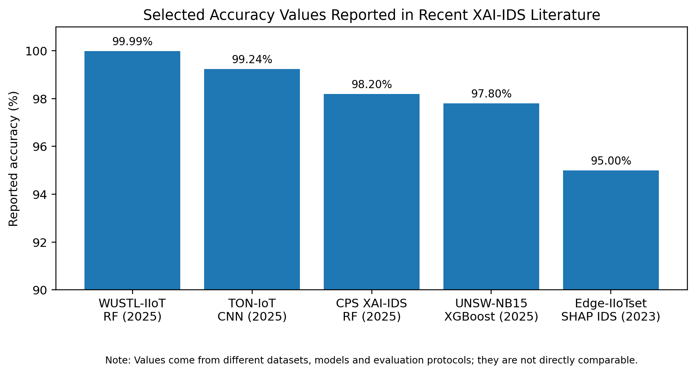

Fig. 2.1 Selected reported accuracy values in recent XAI-IDS literature (not directly comparable)
Table 2.2 compares the principal candidate techniques using the dimensions most relevant to the proposed project. The comparison is intentionally descriptive rather than a ranking: tree ensembles provide strong tabular baselines, MLP provides a neural black-box model, and SHAP/LIME/Anchors/counterfactuals provide different forms of post-hoc explanation. The literature indicates that the choice of explainer can interact with the underlying model, which supports evaluating complete model-XAI combinations rather than treating XAI methods independently [5], [6].
Table 2.2 Comparative Analysis of Existing Methods
Method | Accuracy / Metric |  | Advantages |  | Drawbacks
Random Forest | High accuracy/F1 often reported; fast inference |  | Strong tabular baseline; feature importance; robust to nonlinear patterns |  | Global feature importance is not a full local explanation; can be large.
XGBoost | High accuracy/AUC commonly reported |  | Strong nonlinear modelling; efficient; compatible with SHAP |  | Hyperparameter sensitivity; explanation cost can increase with large samples.
LightGBM | High accuracy with efficient training |  | Fast gradient boosting and scalable to large tabular data |  | Leaf-wise growth can overfit; explanations depend on model/data.
CatBoost | Strong tabular classification |  | Handles categorical features effectively; useful ensemble candidate |  | Higher model complexity than simple baselines; explanation runtime must be measured.
MLP | Competitive IDS classification |  | Flexible nonlinear learner; directly relevant to black-box XAI studies |  | Less transparent; sensitive to preprocessing and tuning.
SHAP | Measures feature contribution; global + local views |  | Additive attribution framework; useful for model comparison |  | Can be computationally expensive; interpretation depends on background/reference data.
LIME | Local surrogate explanation |  | Model-agnostic and intuitive for individual alerts |  | Sampling and locality can cause instability; primarily local.
Anchors | Rule-like local explanations |  | Can produce human-readable sufficient conditions |  | Coverage/precision trade-off; may require many samples.
Counterfactuals | Shows changes that could alter a decision |  | Action-oriented explanations; useful for analyst reasoning |  | Feasibility constraints are important in cybersecurity features.
Evaluation Dimension |  | Why It Matters |  | Proposed Measurement in TrustXAI
Detection performance |  | Confirms that explanations are attached to a useful detector. |  | Accuracy, precision, recall, F1-score, ROC-AUC and confusion matrix.
Fidelity |  | Checks whether the explanation reflects the model's actual behaviour. |  | Prediction change/retention under explanation-guided perturbation.
Stability |  | Checks whether similar inputs produce similar explanations. |  | Similarity of explanations under controlled small perturbations.
Consistency |  | Checks agreement across repeated explanations or related instances. |  | Feature-attribution agreement and rank correlation.
Robustness |  | Checks sensitivity to adversarial or non-semantic perturbations. |  | Performance/explanation change under perturbation scenarios.
Runtime & resources |  | Determines whether explanations are practical for alert processing. |  | Explanation latency, training time, inference time, memory and model size.
Human interpretability |  | Assesses whether explanations can support analyst reasoning. |  | Structured user/analyst evaluation in the optional dashboard stage.

Table 2.3 Proposed evaluation dimensions for TrustXAI

2.4 Research Gap Identification
1. Existing limitations: Many studies emphasize detection accuracy or demonstrate explanation plots without evaluating all relevant trust dimensions together.
- 1. Existing limitations: Many studies emphasize detection accuracy or demonstrate explanation plots without evaluating all relevant trust dimensions together.
- 2. Missing features: Explanation fidelity, stability, consistency, robustness and efficiency are not consistently measured across studies.
- 3. Technical issues: Dataset imbalance, redundant features, model dependence and sensitivity to perturbations can change both predictions and explanations.
- 4. Performance gaps: XAI generation introduces additional computation, so explanation latency must be measured alongside model inference latency.
- 5. Cost issues: Large datasets and expensive explainers can increase memory and processing requirements, affecting practical deployment.
- 6. Security/privacy issues: Explanations may expose sensitive network characteristics, while adversarial changes may affect both predictions and explanations.
- 7. Scalability: A method demonstrated on one dataset or architecture may not generalize to different traffic environments; controlled multi-dataset evaluation is therefore desirable.
[Conclude with a short paragraph explicitly stating the research gap(s) this project intends to address.]

2.5 Summary
The literature review shows that explainable IDS research has progressed from demonstrating that black-box predictions can be interpreted toward measuring whether explanations are faithful, stable, robust and efficient. SHAP and LIME are widely used, while recent work also considers feature selection, federated learning, adversarial robustness, forensic interpretation and human-facing explanations.
The key finding is that no single metric captures trustworthiness. Detection performance, explanation behaviour and operational cost must be considered together. This motivates the proposed TrustXAI framework, which will use controlled Phase II experiments to compare AI-plus-XAI combinations and preserve the individual measurements behind any overall trust score.

CHAPTER 3
PROPOSED METHODOLOGY

3.1 Introduction
TrustXAI is proposed as a comparative evaluation framework rather than a single new classifier. It will accept a cybersecurity dataset, apply a controlled preprocessing pipeline, train several candidate IDS models, generate predictions, and attach one or more XAI methods to the trained models. The resulting explanations will be evaluated quantitatively and, where feasible, through a small human-interpretability study.
The main design principle is separation of concerns. Detection quality will be measured independently from explanation quality, robustness and computational cost. These measurements will then be normalized and combined using a documented trust-score formulation so that the final comparison remains auditable. Phase I defines this architecture and evaluation plan; Phase II will provide the actual experimental measurements.

3.2 Proposed System
The proposed system begins with one or more public cybersecurity datasets. After data cleaning, encoding, normalization and train/test separation, multiple AI models will be trained using the same experimental protocol. Candidate models are Random Forest, XGBoost, LightGBM, CatBoost and MLP because they provide a useful mix of tree-based ensembles and a neural model for black-box explanation studies.
For each model, the framework will record standard IDS metrics and generate local and global explanations using selected XAI methods. SHAP is included because it provides additive feature attributions and can support global and local analysis. LIME is included because it provides model-agnostic local surrogate explanations. Anchors and counterfactuals are considered as optional extensions if implementation time and dataset characteristics permit.
Novelty is positioned at the evaluation level: TrustXAI will compare the complete combinations of detector and explainer and retain separate measurements for predictive performance, explanation fidelity, stability, robustness, runtime and resource usage. The framework is therefore intended to answer a broader research question than simple attack-classification accuracy.

3.3 System Architecture
Figure 3.1 presents the proposed TrustXAI architecture, showing the progression from cybersecurity data to model predictions, explanations, trust evaluation and comparative reporting.
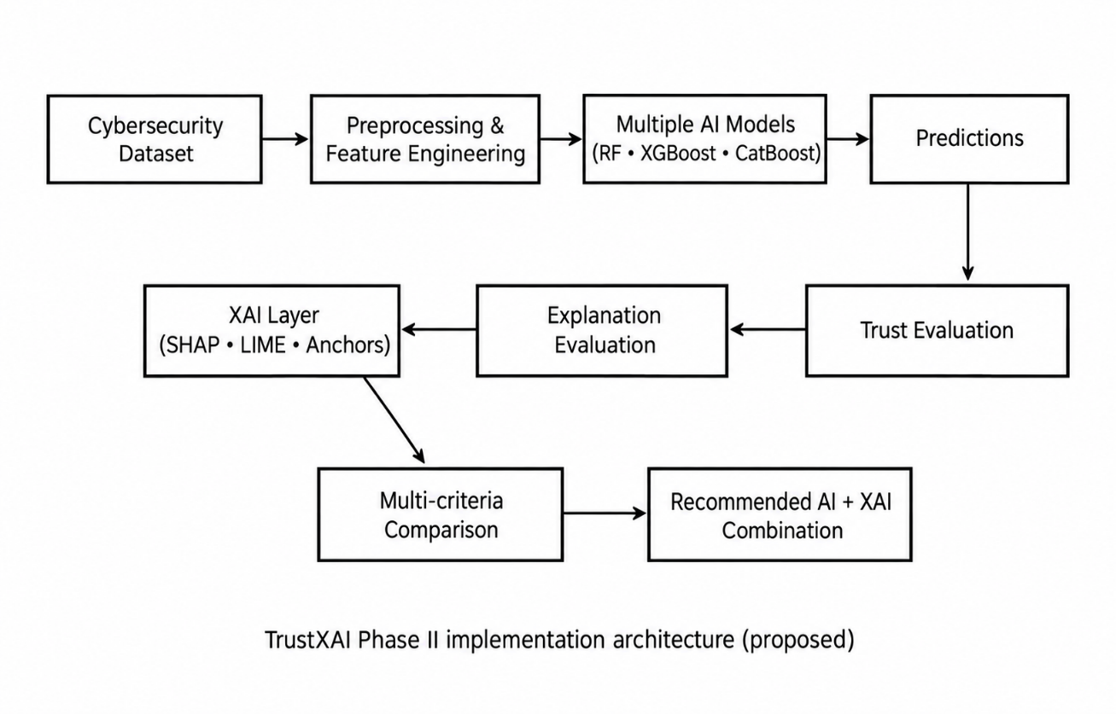
Fig. 3.1 System Architecture
Figure 3.2 presents the proposed data and evaluation flow for Phase II implementation.
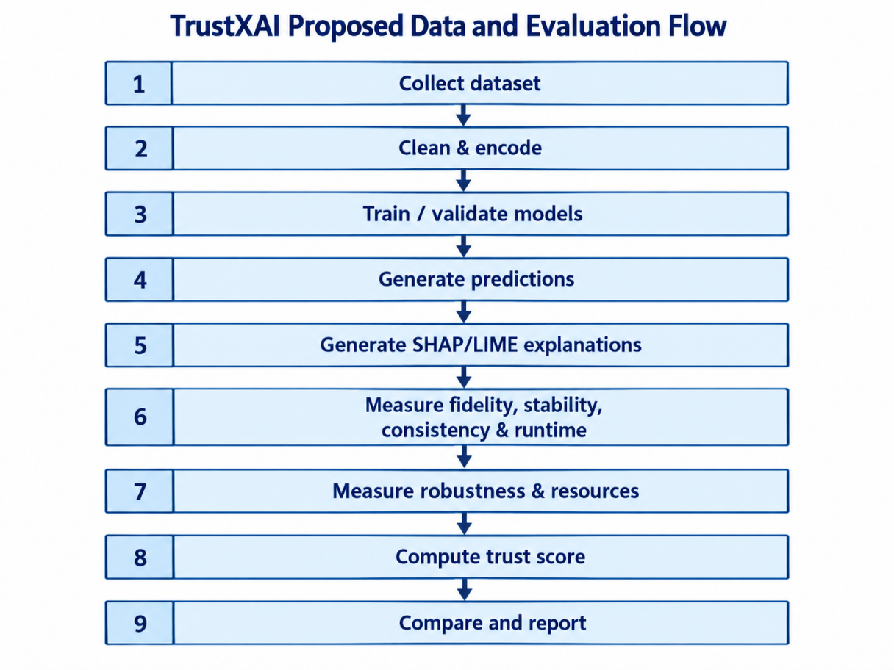
Fig. 3.2 Data Flow Diagram

3.4 Methodology
The Phase II methodology will follow the sequence below.
1. Data Collection: Candidate datasets will be downloaded from their official or research-hosted sources. CICIDS2017, UNSW-NB15, TON_IoT and Edge-IIoTset are considered because they cover different network, IoT and IIoT environments.
2. Data Preprocessing: Duplicate records, missing values, invalid entries and inconsistent labels will be handled. Categorical fields will be encoded, numerical features will be scaled where required, and class distributions will be inspected before model training.
3. Feature Engineering and Selection: Highly redundant or unusable fields will be removed. Feature selection may be guided by correlation analysis and model-independent or XAI-based importance analysis, but selection will be performed without leaking test-set information.
4. Model Development: Random Forest, XGBoost, LightGBM, CatBoost and MLP will be trained using a consistent train/validation/test protocol. Hyperparameter tuning will be documented rather than tuned separately to maximise a single metric without controls.
5. Prediction and Detection Evaluation: Each model will generate attack/normal or multiclass predictions. Accuracy, precision, recall, F1-score, ROC-AUC and confusion matrices will be recorded, with macro-averaged metrics used where class imbalance makes overall accuracy misleading.
6. Explanation Generation: SHAP and LIME will be applied to selected models and samples. Global feature importance and local alert-level explanations will be stored in a common format so that explanation methods can be compared.
7. Explanation Evaluation: Fidelity, stability, consistency, sparsity and runtime will be measured as applicable. Perturbation tests will examine whether an explanation remains meaningful when non-semantic changes are introduced.
8. Robustness and Resource Evaluation: Model and explanation behaviour will be tested under controlled perturbations. Training time, inference latency, explanation latency, memory use and model size will be measured using the same hardware environment.
9. Trust-Score Computation: Individual measurements will be normalized to comparable ranges. The final trust score will be computed using a documented weighted formulation, while the underlying metrics will remain visible so that the score is not treated as a substitute for the raw evidence.
10. Comparative Analysis: Every feasible model-XAI combination will be compared using the same protocol. The final report will identify trade-offs and context-dependent suitability rather than assuming that one combination is universally optimal.
- Data Collection
- Data Preprocessing
- Feature Engineering
- Model Development
- Prediction
- Evaluation
The numbered process above defines the proposed implementation sequence. The exact preprocessing choices, hyperparameters, perturbation protocol and trust-score weights will be documented during Phase II so that the final experiments remain reproducible.

3.5 Algorithms / Techniques Proposed
Random Forest: A bagging ensemble of decision trees that is suitable for tabular network-flow data and provides a strong, relatively robust baseline.
XGBoost: A gradient-boosted tree framework capable of modelling nonlinear feature interactions and commonly effective on structured tabular data.
LightGBM: A gradient-boosting method designed for efficient training on large datasets. It is included to evaluate the effect of training and inference efficiency.
CatBoost: A gradient-boosting algorithm that can handle categorical variables effectively and provides another ensemble family for comparison.
Multi-Layer Perceptron (MLP): A feed-forward neural network that provides a useful black-box model for studying post-hoc explanation methods and complements the tree-based models.
SHAP: An additive feature-attribution framework based on Shapley values. It will be used for global feature importance and local prediction explanations where computationally feasible.
LIME: A model-agnostic local explanation method that fits an interpretable surrogate model around an individual prediction. It will be used primarily for alert-level explanations.
Anchors: A rule-oriented local explanation approach that can produce human-readable sufficient conditions for a prediction. It is considered as an optional extension.
Counterfactual Explanations: Explanations that describe changes to input features that could alter a prediction. In cybersecurity, feasibility constraints will be required because not every numerical feature change represents a physically possible network event.
Trust-Score Framework: A project-defined multi-criteria evaluation layer that combines normalized detection, explanation, robustness, stability and efficiency measures. The weights and normalization rules will be documented and subjected to sensitivity analysis.

3.6 Software Requirements
- 1. Python 3.x with pandas, NumPy, scikit-learn, XGBoost, LightGBM and CatBoost.
- 2. SHAP and LIME libraries for post-hoc explanation generation.
- 3. Jupyter Notebook and/or Visual Studio Code for development and experiment tracking.
- 4. Matplotlib and Plotly/Seaborn for result visualization; Excel or equivalent may be used for tabulation.
- 5. Git for version control and experiment reproducibility.
- 6. Optional: Streamlit for the Phase II demonstration dashboard.

3.7 Hardware Requirements
- 1. Intel Core i5 / AMD Ryzen 5 or higher processor.
- 2. Minimum 8 GB RAM; 16 GB or more is recommended for larger datasets and XAI calculations.
- 3. Windows 10/11 or a current Linux distribution; a GPU is optional because the initial candidate models are primarily tabular ML models.
- 4. At least 20 GB free storage for datasets, notebooks, models and explanation outputs; SSD recommended.

3.8 Work Plan
The following five-month plan covers the major Phase II implementation and documentation activities.

Table 3.1 Project Work Plan (Gantt Chart)
Activity | Month 1 | Month 2 | Month 3 | Month 4 | Month 5
Literature Review | ✓
Dataset Collection | ✓ | ✓
Dataset Cleaning & EDA |  | ✓ | ✓
Model Development |  |  | ✓ | ✓
XAI & Trust Evaluation |  |  |  | ✓ | ✓
Testing & Validation |  |  |  | ✓ | ✓
Documentation / Paper |  |  |  |  | ✓

CHAPTER 4
CONCLUSION AND FUTURE WORK

4.1 Summary
Phase I established that AI-based IDS can provide strong detection performance, but accuracy alone does not provide sufficient evidence for operational trust. The literature review found substantial work on SHAP, LIME and other XAI methods, including applications to IoT, IIoT, cloud, maritime and cyber-physical environments. It also showed that explanation fidelity, stability, robustness, efficiency and human interpretability are increasingly recognized as important evaluation dimensions.
Based on this review, TrustXAI is proposed as a comparative framework that keeps detection performance, explanation quality, robustness and computational cost as separate measurable dimensions before combining them into a transparent trust-oriented evaluation. The proposed methodology includes controlled preprocessing, multiple candidate IDS models, multiple XAI techniques, quantitative explanation evaluation and resource measurement.

4.2 Expected Contribution
The anticipated contribution is a reproducible evaluation framework for comparing AI-plus-XAI combinations in cyber threat detection. Rather than presenting a single accuracy value or a single explanation plot, the project will retain evidence across detection, explanation and operational dimensions. The framework is expected to help researchers understand trade-offs between different model families and XAI methods and to provide a clearer basis for selecting an approach for a particular IDS scenario.
A second contribution is the explicit separation between an individual metric and the overall trust score. This is intended to prevent a composite score from hiding weaknesses such as poor recall, unstable explanations or excessive explanation latency.

4.3 Future Implementation Plan
Project Phase II will begin with final dataset selection and preprocessing. The selected datasets will be cleaned, encoded and split using leakage-aware procedures. Multiple candidate models will then be trained and evaluated using common metrics. SHAP and LIME will be integrated first, followed by optional Anchors and counterfactual explanations if the experimental scope remains manageable.
The next stage will measure explanation fidelity, stability, consistency, robustness and runtime. Resource consumption will be recorded for model training, inference and explanation generation. A documented trust-score formulation will then be applied, followed by sensitivity analysis of the score weights. The final outputs will include tables, confusion matrices, ROC curves, explanation plots, runtime/resource graphs and a comparison dashboard if feasible. The final phase will consolidate the results into the project report and an IEEE-style research paper.

REFERENCES
[1] S. Neupane, J. Ables, W. Anderson, S. Mittal, et al., “Explainable Intrusion Detection Systems (X-IDS): A Survey of Current Methods, Challenges, and Opportunities,” IEEE Access, vol. 10, pp. 112392–112415, 2022, doi: 10.1109/ACCESS.2022.3216617.
[2] N. Capuano, G. Fenza, V. Loia, and C. Stanzione, “Explainable Artificial Intelligence in CyberSecurity: A Survey,” IEEE Access, vol. 10, pp. 93575–93600, 2022, doi: 10.1109/ACCESS.2022.3204171.
[3] Z. Abou El Houda, B. Brik, and L. Khoukhi, “Why Should I Trust Your IDS?: An Explainable Deep Learning Framework for Intrusion Detection Systems in Internet of Things Networks,” IEEE Open Journal of the Communications Society, vol. 3, pp. 1164–1176, 2022, doi: 10.1109/OJCOMS.2022.3188750.
[4] E. C. Nkoro, J. N. Njoku, C. I. Nwakanma, J.-M. Lee, and D.-S. Kim, “SHAP-Based Intrusion Detection Framework for Zero-Trust IoT Maritime Security,” 2023.
[5] O. Arreche et al., “E-XAI: Evaluating Black-Box Explainable AI Frameworks for Network Intrusion Detection,” IEEE Access, vol. 12, pp. 23954–23988, 2024, doi: 10.1109/ACCESS.2024.3365140.
[6] D. Gaspar, P. Silva, and C. Silva, “Explainable AI for Intrusion Detection Systems: LIME and SHAP Applicability on Multi-Layer Perceptron,” IEEE Access, vol. 12, pp. 30164–30175, 2024, doi: 10.1109/ACCESS.2024.3368377.
[7] X. Chen, M. Liu, Z. Wang, and Y. Wang, “Explainable Deep Learning-Based Feature Selection and Intrusion Detection Method on the Internet of Things,” Sensors, vol. 24, no. 16, 5223, 2024, doi: 10.3390/s24165223.
[8] D. Attique, H. Wang, P. Wang, D. Javeed, and M. Adil, “EX-DFL: An Explainable Deep Federated-based Intrusion Detection System for Industrial IoT,” in Proc. 21st International Joint Conference on Computer Science and Software Engineering (JCSSE), 2024, pp. 358–364, doi: 10.1109/JCSSE61278.2024.10613665.
[9] M. Al-Hawawreh and N. Moustafa, “Explainable Deep Learning for Attack Intelligence and Combating Cyber–Physical Attacks,” Ad Hoc Networks, vol. 153, 103329, 2024, doi: 10.1016/j.adhoc.2023.103329.
[10] P. Hermosilla, S. Berríos, and H. Allende-Cid, “Explainable AI for Forensic Analysis: A Comparative Study of SHAP and LIME in Intrusion Detection Models,” Applied Sciences, vol. 15, no. 13, 7329, 2025, doi: 10.3390/app15137329.
[11] A. Alabbadi and F. Bajaber, “An Intrusion Detection System over the IoT Data Streams Using eXplainable Artificial Intelligence (XAI),” Sensors, vol. 25, no. 3, 847, 2025, doi: 10.3390/s25030847.
[12] D. Goyal, S. K. Singh, S. Kumar, V. Chilkoti, K. T. Chui, C. H. Hsu, and B. B. Gupta, “An Explainable AI Framework for Intrusion Detection Using SHAP and LIME,” in Proc. IEEE 14th Global Conference on Consumer Electronics (GCCE), 2025, pp. 1315–1319, doi: 10.1109/GCCE65946.2025.11275089.
[13] M. A. Rahman, G. Francia, H. Shahriar, E. El-Sheikh, A. Cuzzocrea, and S. I. Ahamed, “Explaining Network Intrusion Detection System with SHAP and LIME,” in Proc. IEEE International Conference on Big Data (BigData), 2025, pp. 4325–4332, doi: 10.1109/BigData66926.2025.11401474.
[14] R. Haoda, S. N. H. S. Abdullah, Q. Jiale, T. A. M. T. Ariffin, and K. A. Z. Ariffin, “Towards Transparent Intrusion Detection: The Role of Explainable AI,” in Proc. 3rd International Conference on Cyber Resilience (ICCR), 2025, doi: 10.1109/ICCR67387.2025.11292009.
[15] “A Robust and Trustworthy Intrusion Detection System Using Adversarial Machine Learning and XAI,” in Proc. International Conference on Advanced Technologies for Communications (ATC), 2024, doi: 10.1109/ATC63255.2024.10908263.
[16] “Explainable AI in Cybersecurity: A Comprehensive Framework for Enhancing Transparency, Trust, and Human-AI Collaboration,” in Proc. International Seminar on Application for Technology of Information and Communication (iSemantic), 2024, doi: 10.1109/iSemantic63362.2024.10762690.
[17] I. Sharafaldin, A. H. Lashkari, and A. A. Ghorbani, “Toward Generating a New Intrusion Detection Dataset and Intrusion Traffic Characterization,” in Proc. 4th International Conference on Information Systems Security and Privacy (ICISSP), 2018.
[18] N. Moustafa and J. Slay, “UNSW-NB15: A Comprehensive Data Set for Network Intrusion Detection Systems (UNSW-NB15 Network Data Set),” in Proc. Military Communications and Information Systems Conference (MilCIS), 2015, pp. 1–6, doi: 10.1109/MILCIS.2015.7348942.
[19] M. A. Ferrag et al., “TON_IoT Telemetry Dataset: A New Generation Dataset of IoT and IIoT for Data-Driven Intrusion Detection Systems,” IEEE Access, 2021.
[20] M. A. Ferrag et al., “Edge-IIoTset: A New Comprehensive Realistic Cyber Security Dataset of IoT and IIoT Applications for Centralized and Federated Learning,” IEEE Access, vol. 10, pp. 40281–40306, 2022, doi: 10.1109/ACCESS.2022.3165809.
[21] S. M. Lundberg and S.-I. Lee, “A Unified Approach to Interpreting Model Predictions,” in Advances in Neural Information Processing Systems, vol. 30, 2017.
[22] M. T. Ribeiro, S. Singh, and C. Guestrin, “Why Should I Trust You?: Explaining the Predictions of Any Classifier,” in Proc. 22nd ACM SIGKDD International Conference on Knowledge Discovery and Data Mining, 2016, pp. 1135–1144.
[23] S. Wachter, B. Mittelstadt, and C. Russell, “Counterfactual Explanations without Opening the Black Box: Automated Decisions and the GDPR,” Harvard Journal of Law & Technology, vol. 31, pp. 841–887, 2018.

[1] A. Author, B. Author, and C. Author, “Title of the paper,” Name of Journal, vol. X, no. Y, pp. XX–XX, Year.
[2] A. Author and B. Author, “Title of the conference paper,” in Proc. Name of Conference, City, Country, Year, pp. XX–XX.
[3] [Continue numbering through reference 15–30...]

APPENDICES

Appendix B — Dataset Description
The final dataset will be selected after a short Phase II data-quality assessment. The current candidate set is:
CICIDS2017: A labelled network-flow dataset containing benign traffic and several common attack families, with more than 80 flow features generated using CICFlowMeter. It is useful for conventional network IDS benchmarking and is widely used in XAI-IDS literature.
UNSW-NB15: A network intrusion dataset generated from modern normal activity and synthetic attack behaviour. The source reports 49 features and nine attack categories, with separate training and testing files available. It provides a complementary benchmark to CICIDS2017.
TON_IoT: A heterogeneous telemetry dataset designed for IoT and IIoT security research. It contains network and telemetry data from multiple device and operating contexts and is useful for evaluating whether conclusions generalize beyond conventional enterprise traffic.
Edge-IIoTset: An IoT/IIoT cybersecurity dataset created from a purpose-built testbed. It includes multiple device types, protocols and attack categories and supports centralized and federated-learning studies. The dataset paper reports 1,176 extracted features before a reduced set of 61 proposed features.
Selection criteria will include label quality, class distribution, feature availability, computational size, relevance to the project objective, and compatibility with the chosen XAI methods. The final Phase II report will document the exact version, preprocessing steps and train/test protocol used.

Appendix B — Additional Diagrams

The following diagram is included as a supplementary view of the proposed workflow.

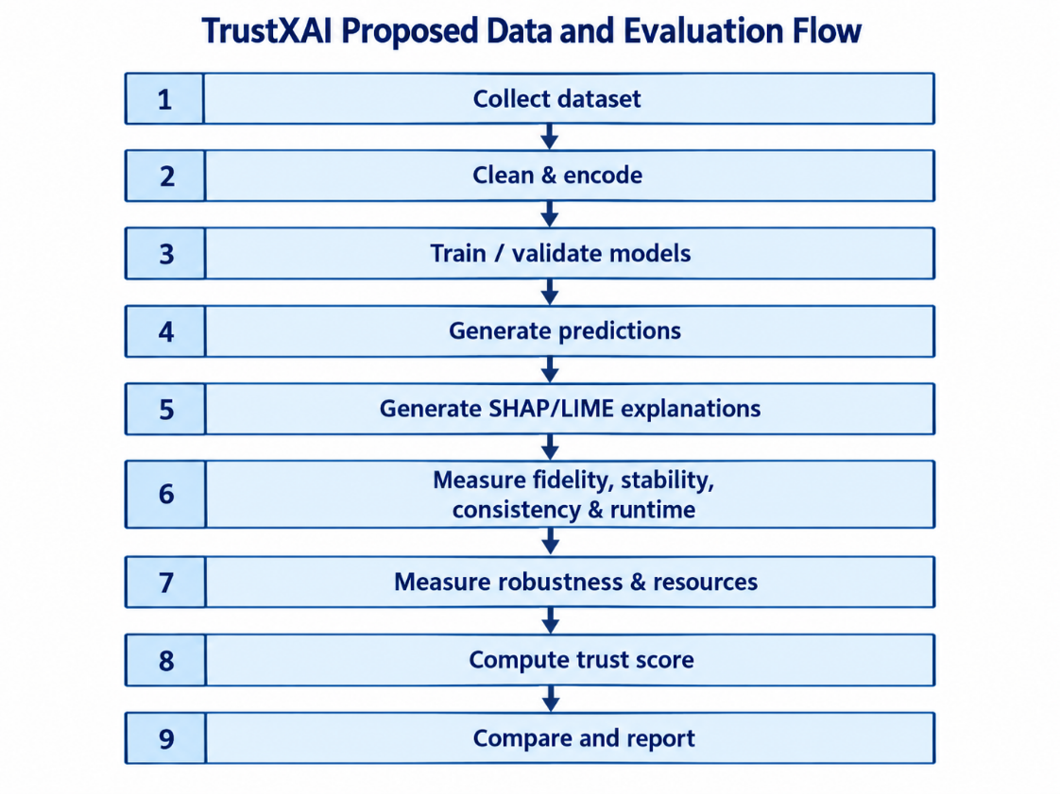
[Include any supplementary diagrams not placed in the main chapters.]

